TITLE of paper
Author(s) Name and Surname
Name of affiliation¹ (10-point font, italic, justification left, typed in lower case letters with initial capitals. Please, do not abbreviate names), address, e-mail.

Abstract: a single paragraph of no more than 250 words (style Abstract) presenting the main points and principal conclusions of the paper. Please do not include the word <abstract>.
KEY WORDS: 9-point font in lower case letters, not exceeding 6 words.

notation (Style Heading other)
ab | Distance between A and B (mm)
B | Length (mm)
C | Pressure (Pa)

α | Angle (rad)
σ | Tensile stress (MPa)
τ | Shear stress (MPa)

title of section (Style Heading 1)
Please use Styles when preparing paper. Do not introduce new styles if not necessary. Section titles must use style Heading 1. Body of paper must use style Body text1 (single spacing), consistently through the manuscript. All papers must be prepared on A4 size (210 x 297 mm) white paper with the margins left (4.19 cm), right (4.14 cm), top (3.0 cm) and bottom (8.25 cm). MSWORD 2007 -2013 (*.docx) is the preferred word processing format. The paper should be no longer than 8 pages including figures and tables. All papers must be supplied in electronic format (.docx and .pdf). Please send your contribution to Rainer Haldenwang, Conference chairman, ts19@ctconf.co.za

Title of sub-section (Style Heading 2)
Sub-section titles must use style Heading 2. Please, do not use running headlines, for example do not repeat the title of the paper or the name of an author at the top of each page. Do not number the pages.
All photographs, figures and diagrams should be referred to as Figures and numbered serially with Arabic numerals in the order they are mentioned in the text (use style Figure caption). A complete set of figures suitable for publication (please do not over-reduce) must be included. The Proceedings will be published in black and white only, so these should be original tracings or line drawings in black ink, sharp clean prints or printouts of line drawings, or glossy black and white photographs. It is the responsibility of the author(s) to provide figures suitable for publication. Lines must not be broken, faint or very fine, or they may disappear during the various publication photographic processes. Mount all figures directly into the text at the appropriate places. Each caption should be a brief but complete description of the figure it refers to.
For table numbers use style Table caption number (on a blank line). Insert the table caption on the next line using the style Table caption. For tables use style Body text1 + 9pt, First line : 0 cm.
Notation: if many symbols are used and needed in the text, rather define these in an alphabetical list (Roman letters first, then Greek letters) in a section headed NOTATION right after the abstract (as above) and do not repeat them in the text. Use SI units.
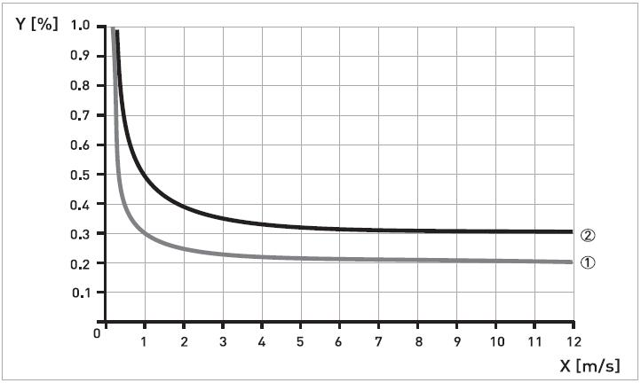
- Flowmeter error data (style Figure caption)

More text
- (style Table caption number)
Heavy metal content in soils (style Table caption)
ab | Distance between A and B (mm)
B | Length (mm)
C | Pressure (Pa)

Next section (style heading 1)
Start new sections (not sub-sections) with a continuous section break (Layout,Breaks, Section breaks, Continuous) to ensure proper numbering. Figure and table numbers are not linked to section numbers and will just increment, as shown below.

Next sub-section (Style heading 2)
Sub-setion text (style Body text1).
- (table number - style Table caption number)
Table 2 caption (style Table caption)

Next sub-section (Style heading 2)
Sub-setion text.

- Values of Manning’s coefficient for a range in water (style figure caption)
- (style table caption number)
Heavy metal content in soils (style table caption)

ACKNOWLEDGEMENTS (style heading other)
The authors would like to thank the Dredging section of the Delft University of Technology for supplying this format and FPRC, CPUT for updating the template.
References (style heading other)
All publications cited in the text should be presented in alphabetical order of the authors. In the text make references by name and year, e.g. Lee and Bankoff (1984), Powell et al. (1995).

References should be listed as shown below (style References):

- Hlastala, M.P., Berger, A.J., 1996. Physiology of Respiration, Oxford University Press, London.
- Lee, S.C., Bankoff, S.G., 1984. Parametric effects on the onset of flooding in flat-plate geometries. Int.J. Heat Mass Transfer 27, 1691-1700.
- Powell, C., Blair, T., Bush, G., 1995. Measurements of the interfacial waves. Proc. 3rd Int. Conf. on Multiphase Flow, Eds.:Suzuki,T.,Aoki,R., Yokohama (Japan), 2-5 May 1995, CD-ROM, #123.

